**Data Processing**

**Reading 2 Questions**

Mounir Hader - 10254925

1.

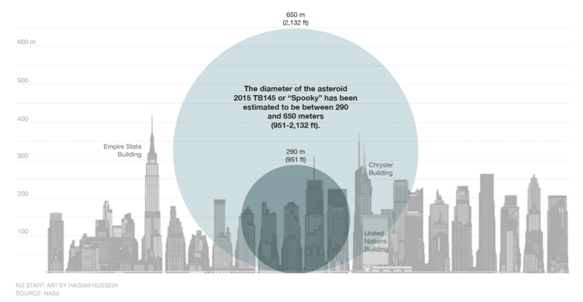

<http://news.nationalgeographic.com/2015/10/151023-astronomy-asteroid-encounter-Earth-stargazing-nasa/>

2. **Size:** the (estimated) size range of the asteroid becomes very clear by using 2 circles of different size, while maintaining the scaling on the y-axis.

**Colour:** by using different circle colours it becomes even more obvious that the size of the asteroid can vary between certain values. By choosing the same colour for all skyscrapers they are easily distinguished from the circles, which are the main elements in this visialization.

3. This visualiation intends to illustrate the size of an asteroid by comparing it to New York skyscrapers. In doing so, the visualization doesn’t make use of specific terms that belong in some specific *domain*. Therefore we can conclude that the main concepts of this visualization are understandable for everyone.

The *data type* chosen to illustrate the asteroid seems legit: (most) people will probably associate an asteroid with a circular size. The skyscrapers on the background serve as comparison material. By using such a reference frame the user will more easily conceptualize and truly understand how big the size of the meteor really is.

4. The visualization embodies clear practices, in that it allows the user to accurately extract quantitative information from the graph (i.e., the asteroid’s size). This also is the only task the user should perform with this visualization (a low-level abstract task): to understand how big the asteroid is and maybe also to compare it to buildings that are less imaginative and more conceptualized for people.

5. I certainly agree to that. Visualization clearly is a very functional tool to make certain numbers/concepts understandable to the user. By being appealing to the eye as well, it attracts users much more to extract information from it.

6. The designer intends to show the user the size of the asteroid, and more importantly, to make the user realize how big it really is by using other buildings to compare it to. The user can also learn from the heights of the skyscrapers by reading from the y-axis. By putting both data types in this one graph the designer implicitly shows us the enormous impact this asteroid could have when colliding with the Earth, which can be considered a third task. For me all of these (possible) tasks are achieved by the visualization.